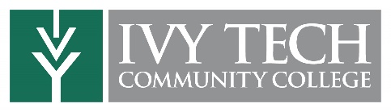

Will Ivy Tech credits transfer?
They will, and they do.
Ivy Tech Community College offers transfer partnerships with I.U., Purdue, Ball State, and many other colleges and universities, inside and outside Indiana. As huge tuition fees (and equally staggering student debts) are making national news, it’s no surprise that many students start at Ivy Tech, then transfer their credits on to four-year institutions. It’s a smart move that can save an individual student upward of $10,000. Collectively, students who start at Ivy Tech save themselves and their families nearly $35 million annually.
2+2 Transfer Agreements
Ivy Tech’s 2+2 Transfer Agreements promote seamless transfer from two-year to four-year degree programs. Students obtain their associate degree at Ivy Tech, then transfer elsewhere to complete their bachelor’s degree.
General Education Core
Our Transfer General Education Core (or TGEC) pathway provides students with a solid core of General Education classes, and is guaranteed to transfer to in-state baccalaureate-degree granting institutions.
Hundreds of other transfer possibilities
Learn more about all of our transfer options—including Distance Education Transfer Programs, Course-To-Course Transfer, Concurrent Admission and Bridge Programs, and Associate of Applied Science (AAS) Transfer opportunities.

